
INTERNSHIP REPORT
UI/UX DESIGN

Submitted by
ANJALI KUMARI
(2CSE36)
25SCS1003004230
Batch(2025-29)

Organization | Codec Technologies Pvt. Ltd.
Internship Role | UI/UX Designer Intern
Duration | 01/07/2026 to 01/08/2026
Program | 1 Month AICTE & ICAC Approved Internship Program
Program Manager | Dr. Anurag Shrivastava

Certificate
The internship certificate issued by Codec Technologies Pvt. Ltd. confirms that Anjali Kumari completed a 1 Month AICTE & ICAC Approved internship program as a UI/UX Designer Intern, conducted from 01/07/2026 to 01/08/2026.
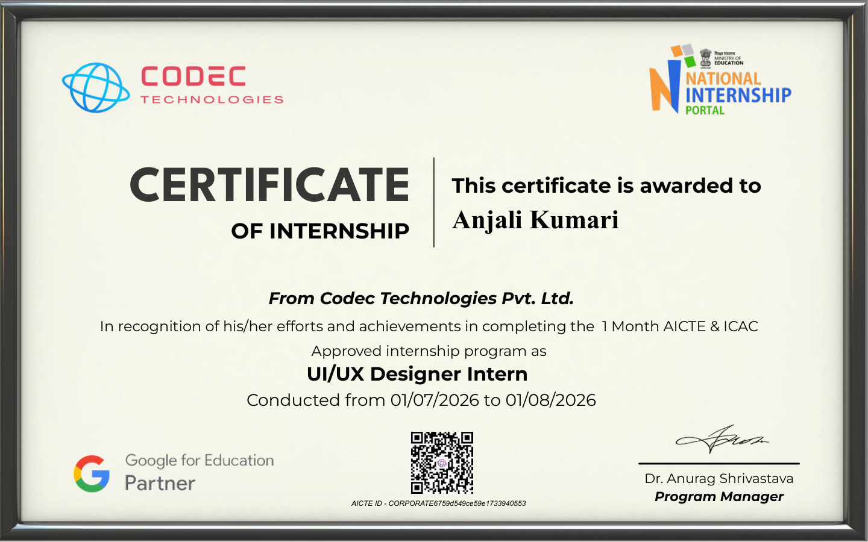

Declaration
I, Anjali Kumari, declare that this internship report is prepared as a formal record of my internship as a UI/UX Designer Intern at Codec Technologies Pvt. Ltd. The internship period stated in this report is based on the internship certificate issued by the organization.
Date: 10/09/2026
Place: ___________________
Signature: __________________________

Acknowledgement
I would like to express my sincere gratitude to Codec Technologies Pvt. Ltd. for providing me the opportunity to undertake a one-month internship as a UI/UX Designer Intern. I am thankful to Dr. Anurag Shrivastava, Program Manager, for the guidance and support associated with the internship program. This experience provided an opportunity to understand the professional context of UI/UX design and to develop a structured approach toward design-related work.

Abstract
This report presents an overview of my one-month internship as a UI/UX Designer Intern at Codec Technologies Pvt. Ltd. The internship was conducted from 01 July 2026 to 01 August 2026 under a 1 Month AICTE & ICAC Approved internship program. The report introduces the UI/UX design field, describes the role and its objectives, and summarizes the major design concepts relevant to the internship. The certificate confirms the internship role and duration; detailed project names, tools, deliverables, and day-wise tasks are not specified on the certificate and therefore are not represented as verified facts in this report.

1. Introduction
UI/UX design focuses on creating digital experiences that are useful, understandable, accessible, and visually coherent. User Interface (UI) deals primarily with the visual and interactive elements of a digital product, while User Experience (UX) considers how effectively and comfortably users can complete their goals.

2. Internship Details
Particular | Details
Organization | Codec Technologies Pvt. Ltd.
Internship Role | UI/UX Designer Intern
Duration | 01/07/2026 to 01/08/2026
Program | 1 Month AICTE & ICAC Approved Internship Program
Program Manager | Dr. Anurag Shrivastava

3. Objectives of the Internship
- Understand the basic principles of UI and UX design.
- Develop awareness of user-centered design and usability.
- Understand the stages involved in planning and designing digital interfaces.
- Improve visual communication, layout, hierarchy, and consistency in interface design.
- Gain exposure to the professional expectations of a UI/UX Designer Intern.

4. UI/UX Design Concepts
User Research: Understanding user needs, goals, behaviors, and pain points before designing a solution.
Information Architecture: Organizing content and navigation so users can find information efficiently.
Wireframing: Creating simple structural layouts to plan the placement and flow of interface elements.
Visual Design: Using typography, spacing, hierarchy, icons, imagery, and other visual elements to communicate clearly.
Prototyping: Representing interactions and user flows so that a design can be evaluated before implementation.
Usability Testing: Checking whether users can understand and complete important tasks easily.
Responsive Design: Designing interfaces that remain usable across different screen sizes and devices.

5. Role: UI/UX Designer Intern
The internship role identified on the certificate is UI/UX Designer Intern. In this role, the expected design workflow generally involves understanding a user problem, planning the information and interaction flow, preparing interface structures, refining visual design, and evaluating the resulting experience.

6. Typical Design Workflow
1. Understand the problem and define the user goal.
2. Gather and organize relevant user or product requirements.
3. Create information structure and user flows.
4. Develop wireframes and initial interface layouts.
5. Create a visual design and interactive prototype.
6. Review usability and refine the design based on feedback.
7. Prepare the final design specification for implementation.

7. Skills and Learning Outcomes
- User-centered thinking and problem identification.
- Better understanding of interface hierarchy and visual consistency.
- Structured approach to wireframes, prototypes, and user flows.
- Awareness of usability, accessibility, and responsive design.
- Improved communication of design decisions.

8. Challenges and Improvements
UI/UX work requires balancing user needs, business or product requirements, and technical feasibility. Common challenges include maintaining simplicity without losing important information, creating consistent layouts, and ensuring that interactions are easy to understand. A useful improvement strategy is to review designs repeatedly, test key user flows, and prioritize clarity over unnecessary visual complexity.

9. Conclusion
The one-month internship at Codec Technologies Pvt. Ltd. provided a formal professional context for the role of UI/UX Designer Intern. The internship certificate verifies completion of the AICTE & ICAC Approved internship program from 01/07/2026 to 01/08/2026. The report summarizes the UI/UX concepts, workflow, and learning areas associated with the role while avoiding unsupported claims about specific projects or tools.

10. Reference / Supporting Document
Internship Certificate issued by Codec Technologies Pvt. Ltd., reproduced in the Certificate section of this report.

